Diesel Jumper -Orange for Women
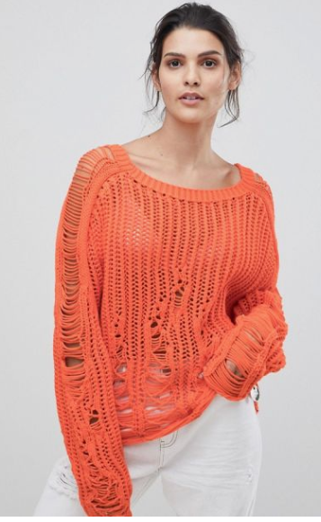
$100

Jumper by Diesel, A cosy wardrobe addition, Ribbed scoop neck, Distressed details, For that worn-in vibe, Relaxed cut, Loose but not oversized. Diesel are renowned globally for their innovative cuts and creative design methods, this distressed jumper from Diesel boasts a round neck, dropped shoulders, long sleeves, distressed details, a logo charm and a loose fit.
Designer Style ID: 00SQYB0LAUE
Colour: 44A orange
Made in Italy
Composition
polyester 80%
polyamide 20%
Washing instructions:
hand wash

